SQL

REST

WEB

UI

(React JS App)

Web

Server

Application

(Spring Boot Application)

DB

(DB2/Maria-DB/Oracle/MySQL/MS-SQL/H2)

Development Environment Check:

Check for node js:

node --version

Check for npm version:

npm --version

Create a Ractjs application

npm init react-app day01-app

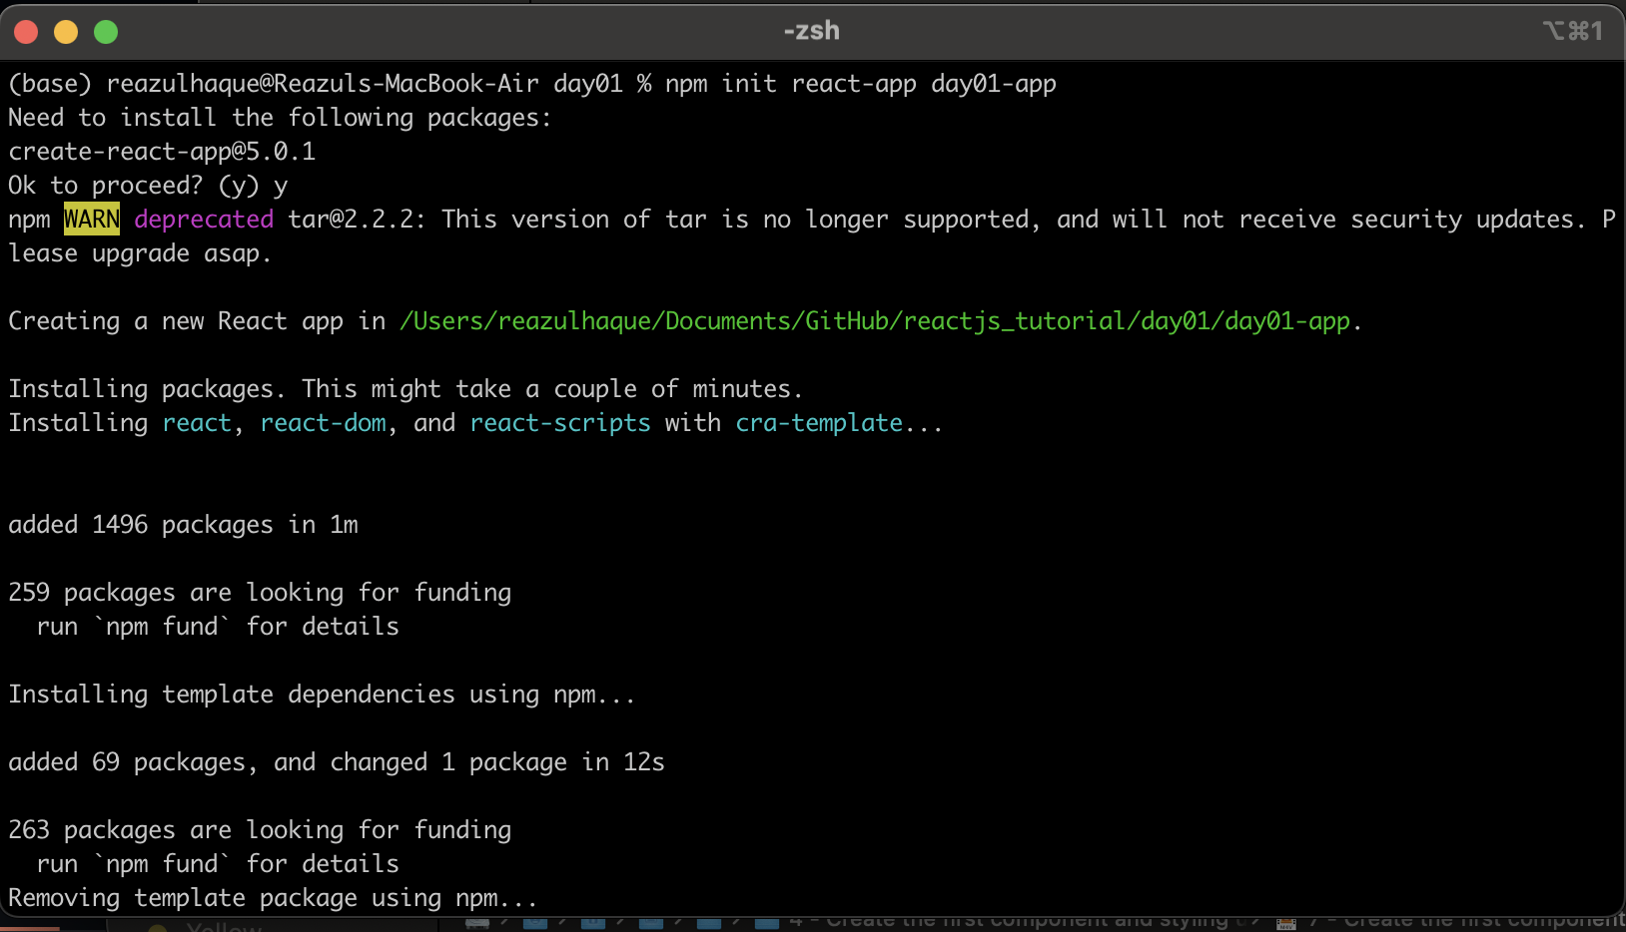

Go to the application folder

cd day01-app

Then run

npm start

This command will run the reactjs application on default port(3000). If the default port used by other application, reactjs will try to use next available port for 3001. It’s a incremental way of searching free port, means next port to serach is 3002, 3003 and so on….

Fig:Reactjs_defaultPage

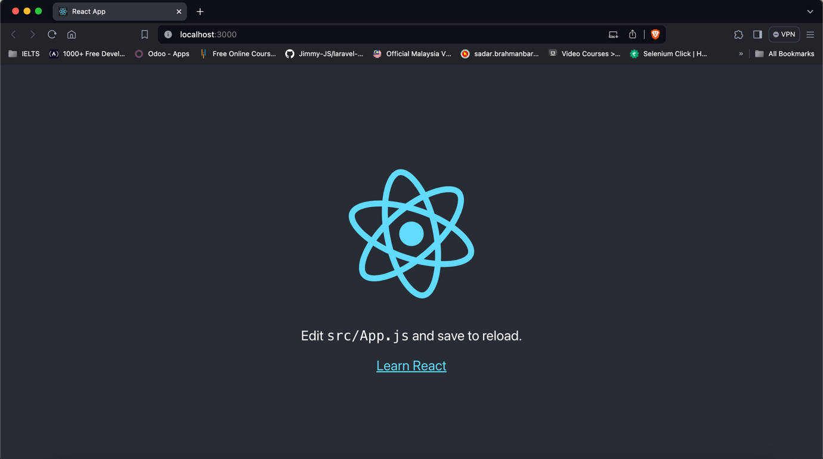

Let’s look to the folder structure:

We’ll use Visual Studio Code (VS Code) for reactjs development, you can also use your favorite IDE for reactjs. Let’s add the application folder to VS code workspace.

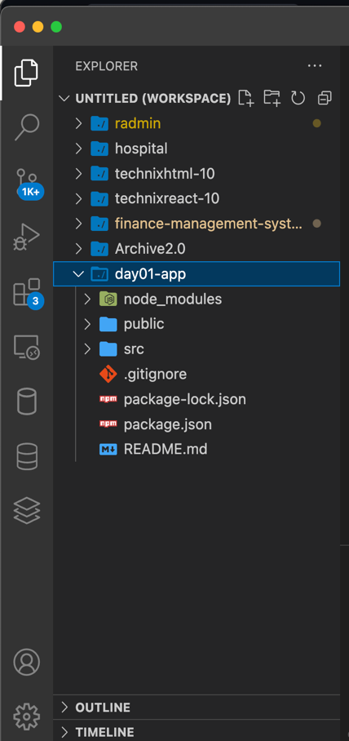

**node_modules**: this folder contains all dependent libraries required by reactjs

**public**: all public files are in public folder

**src**: this is our main folder, where all codes belong.

**.gitignore**: it’s git file for ignoring which file or folder we don’t add to git e.g node_modules folder. We don’t need to add this folder to git.

**package.json**: it’s a dependency manager file like pom.xml. We can add our required library in this file.

**README.md**: default file for git, to describe about the application or whatever comments we want to add for others.

Edit Code:

src/App.js is the default file from reactjs

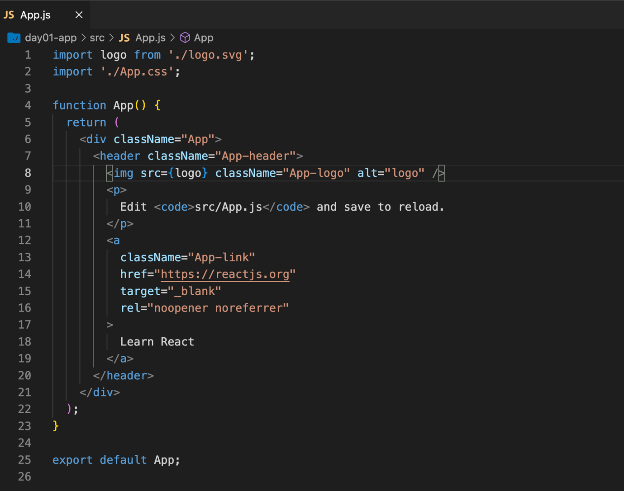

This is the default code by reactjs while we create our application. This code rander in browser as in Fig:Reactjs_defaultPage. Now we’ll add our own code to src/App.js file:

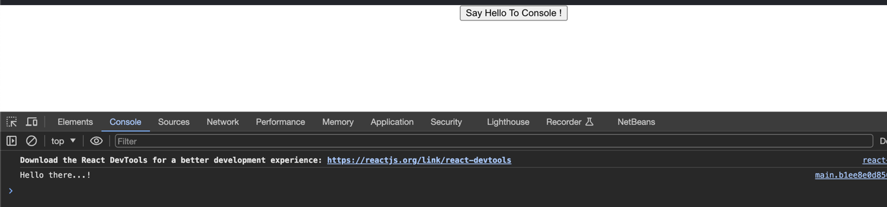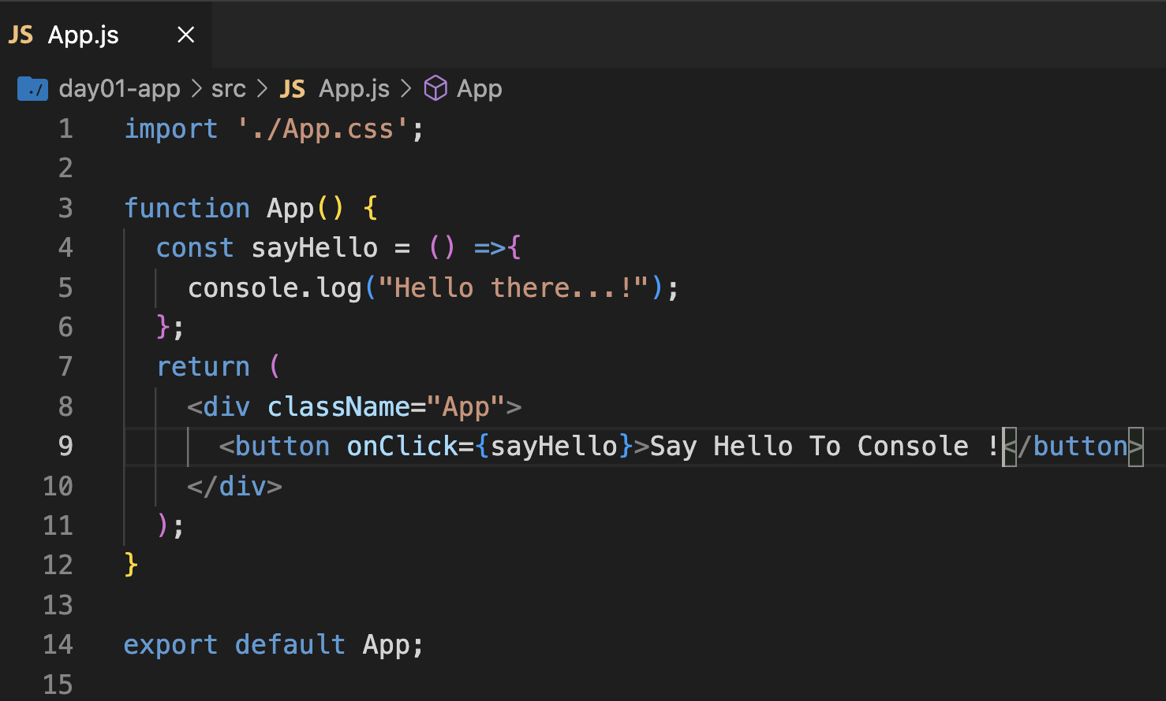

Let’s create our first component:

There are two different ways to implement component one is functional component (which is most popular) other one is class component. We’ll use functional component for learning and development.

Create a js file in src folder name CreateUser.js and the below code:

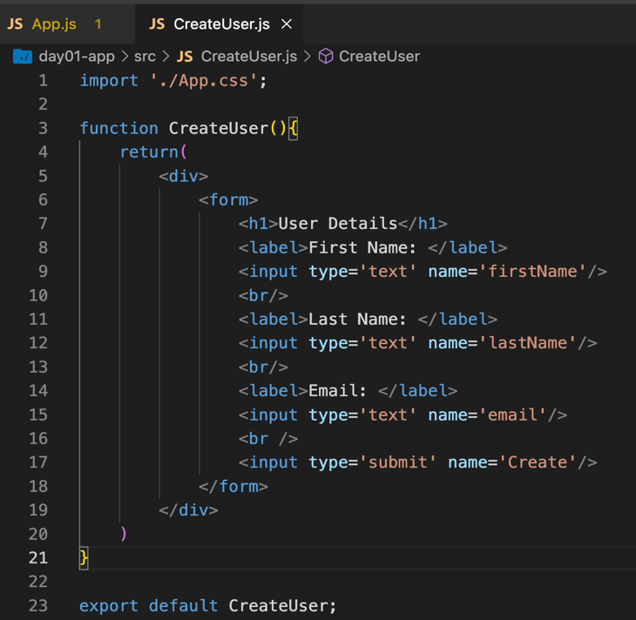

Now, import our newly created component to App.js as in below

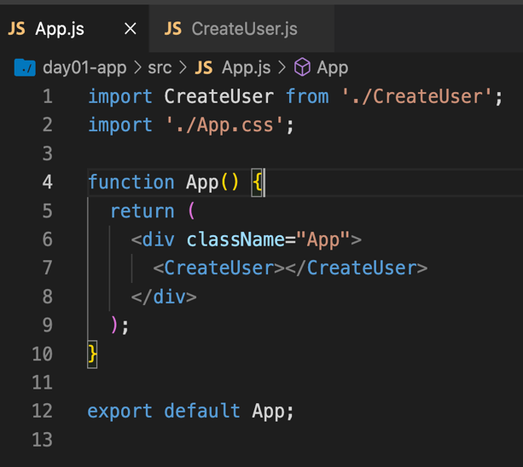

After update the App.js, we’ll get the view as below

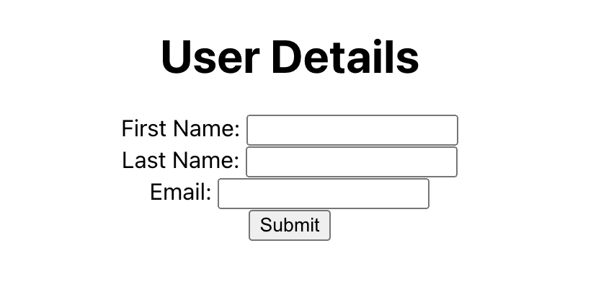

Oops… it’s not a professional look at all, so it’s time to add mighty bootstrap to our project using below command

npm install react-bootstrap bootstrap

We’ll get a view as in below after bootstrap installation

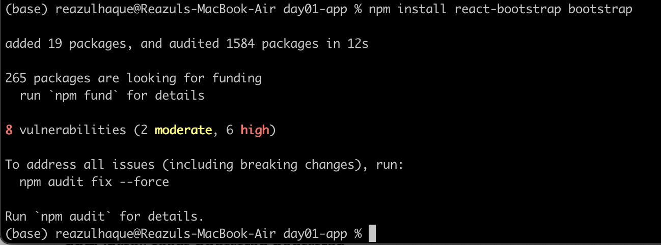

Now, we’ll add bootstrap to our CreateUser component. After adding bootstrap, our CreateUser component will be look like in below

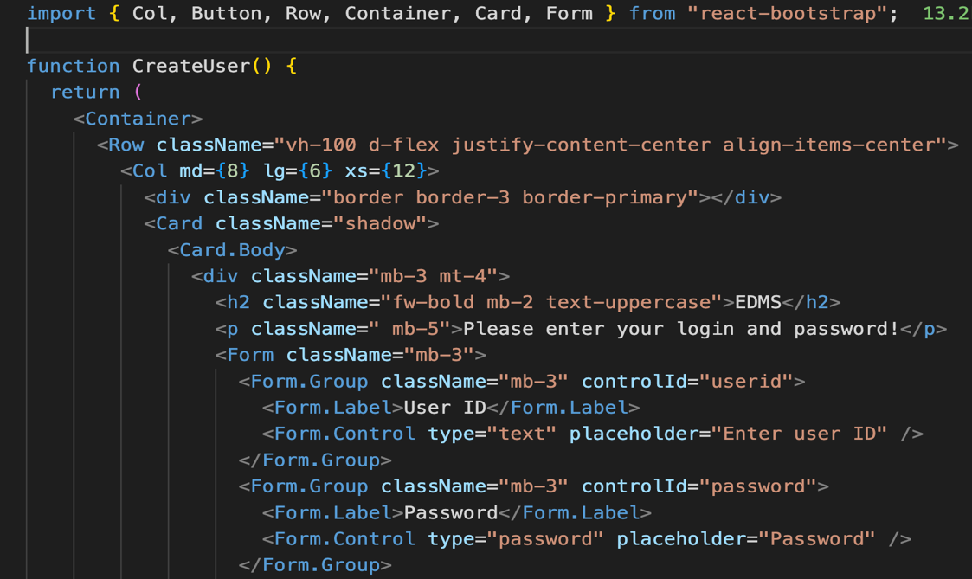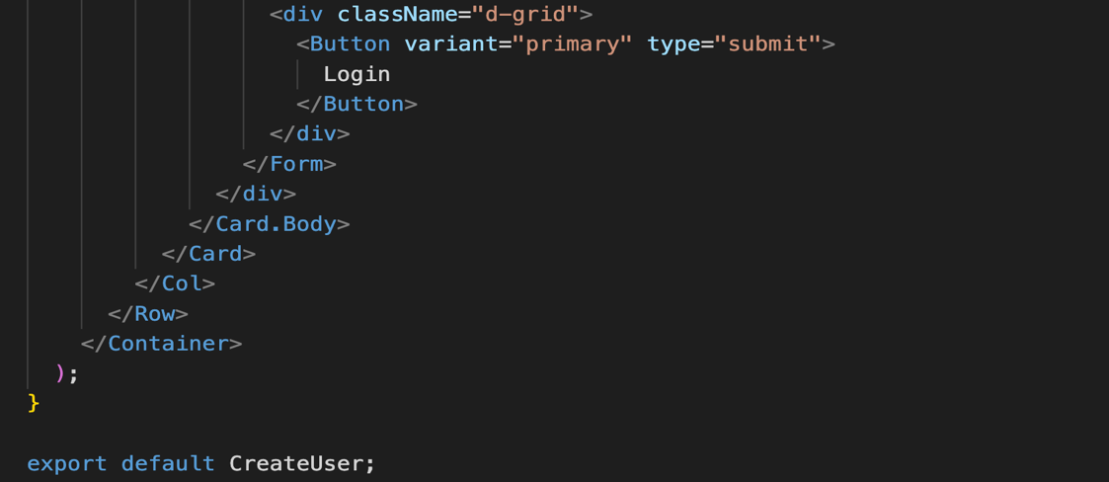

Also need to add bootstrap css to index.js file

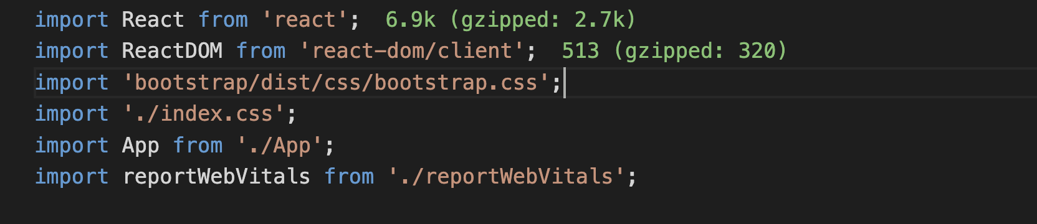

Adding bootstrap css

By adding bootstrap our application looks like below

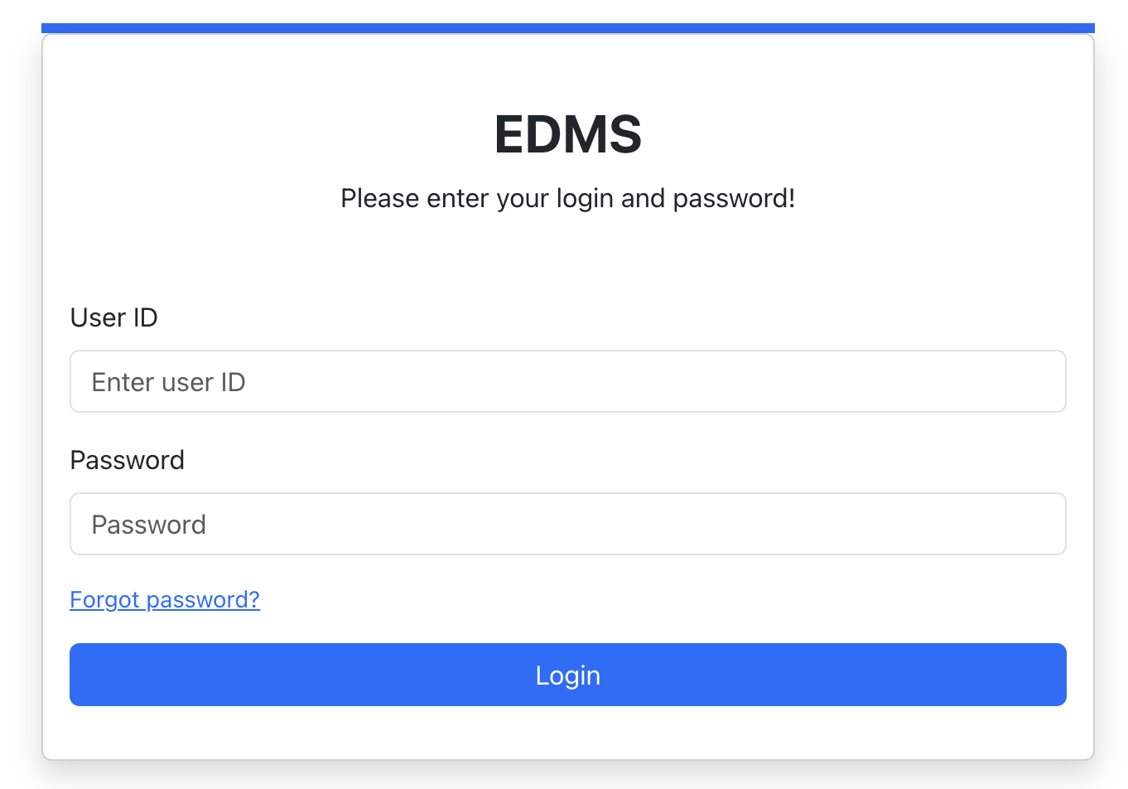

Cool…. You can checkout react-bootstrap official documentation for some awesome design

<https://react-bootstrap.netlify.app/>

Now, we’ll try to add react hook useState. useState is react hook that allows you to add state to a functional component. It returns an array with two values, one is the current state and other is a function to update it. The hook takes an initial state as an argument and returns an updated state value whenever the setter function is called.

Example:

const [userId, setUserId] = useState("");

const [welcomeMsg, setWelcomeMsg] = useState("");

In react, useState can store any type of value, whereas the state in a class component is limited to being an object. This includes primitive data types like string, number and Boolean as well as complex data types such as array, object and function. It can even cover custom data types like class instances. Basically, anything that can be stored in a JavaScript variable can be stored in a state managed by useState.

Updated CreateUser.js File:

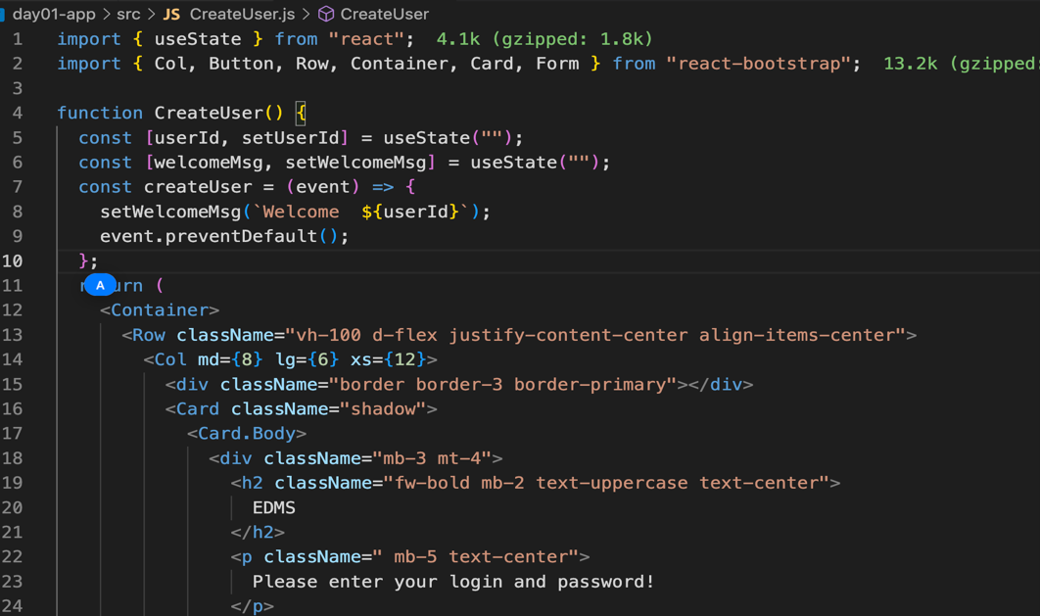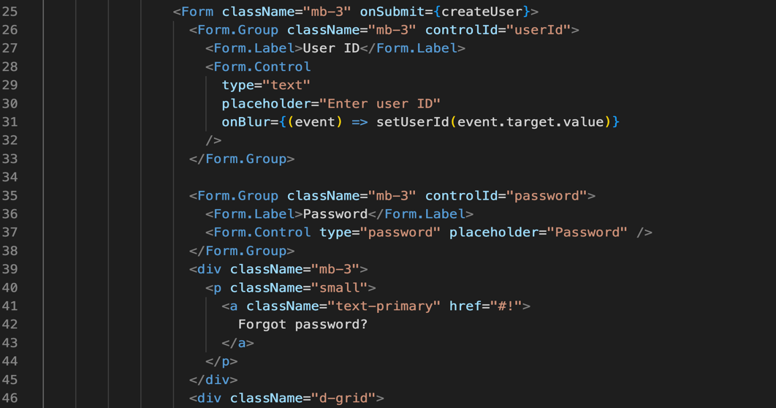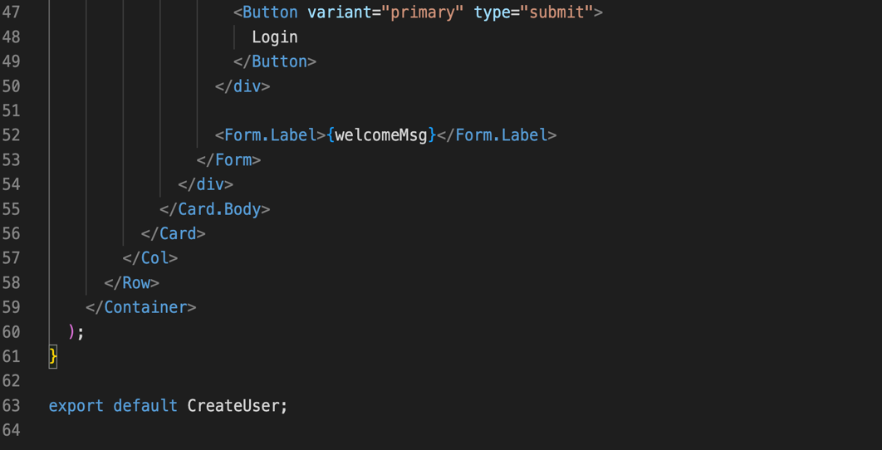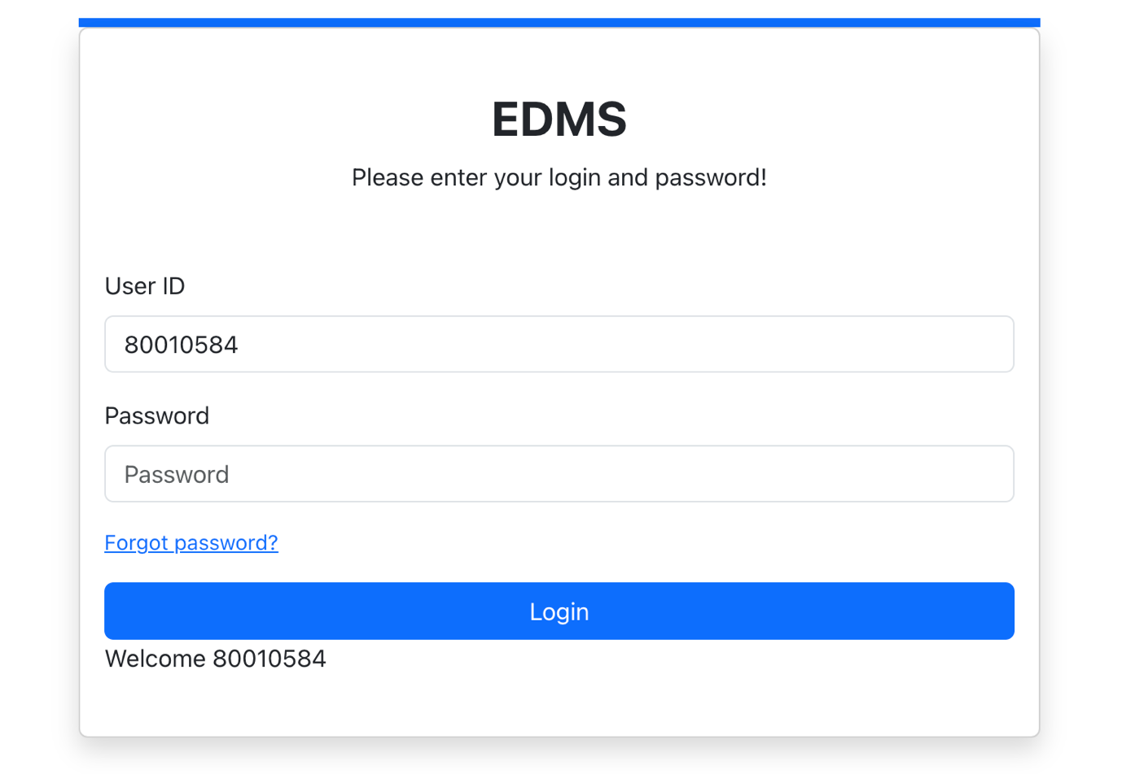

================ Day 02 End ================

Sharing Data Between Two Components using props (Properties)

Let’s create a new component name Message.js

function Message(props){

return(

<label>{props.msg}</label>

);

}

export default Message;

Now it’s time to update our previous CreateUser component

import { useState } from "react";

import { Col, Button, Row, Container, Card, Form } from "react-bootstrap";

import Message from "./Message";

function CreateUser() {

const [userId, setUserId] = useState("");

const [welcomeMsg, setWelcomeMsg] = useState("");

const [civility, setCivility] = useState("Mr");

const createUser = (event) => {

setWelcomeMsg(`Welcome ${civility} ${userId}`);

event.preventDefault();

};

const chooseCivility = (event) => {

setCivility(event.target.value);

}

return (

<Container>

<Row className="vh-100 d-flex justify-content-center align-items-center">

<Col md={8} lg={6} xs={12}>

<div className="border border-3 border-primary"></div>

<Card className="shadow">

<Card.Body>

<div className="mb-3 mt-4">

<h2 className="fw-bold mb-2 text-uppercase text-center">

EDMS

</h2>

<p className=" mb-5 text-center">

Please enter your login and password!

</p>

<Form className="mb-3" onSubmit={createUser}>

<Form.Group className="mb-3" controlId="userId">

<Form.Label>User ID</Form.Label>

<Form.Control

type="text"

placeholder="Enter user ID"

onBlur={(event) => setUserId(event.target.value)}

/>

</Form.Group>

<Form.Group className="mb-3" controlId="password">

<Form.Label>Password</Form.Label>

<Form.Control type="password" placeholder="Password" />

</Form.Group>

<Form.Group className="mb-3" controlId="civility">

<Form.Label>Civility</Form.Label>

<Form.Select aria-label="Default select" onChange={chooseCivility} value={civility}>

<option>Select Civility</option>

<option value="Mr">Mr</option>

<option value="M.">M.</option>

<option value="Mrs">Mrs.</option>

</Form.Select>

</Form.Group>

<div className="mb-3">

<p className="small">

<a className="text-primary" href="#!">

Forgot password?

</a>

</p>

</div>

<div className="d-grid">

<Button variant="primary" type="submit">

Login

</Button>

</div>

{/* <Form.Label>{welcomeMsg}</Form.Label> */}

<Message msg={welcomeMsg}></Message>

</Form>

</div>

</Card.Body>

</Card>

</Col>

</Row>

</Container>

);

}

export default CreateUser;

Destructuring props:

For this one create an new component called Title.js

function Title(props){

console.log(props);

return(

<span>{props.teamName} {props.appName}</span>

);

}

export default Title;

and the CreateUser

……

<h2 className="fw-bold mb-2 text-uppercase text-center">

<Title teamName="EDMS" appName="App"/>

</h2>

……

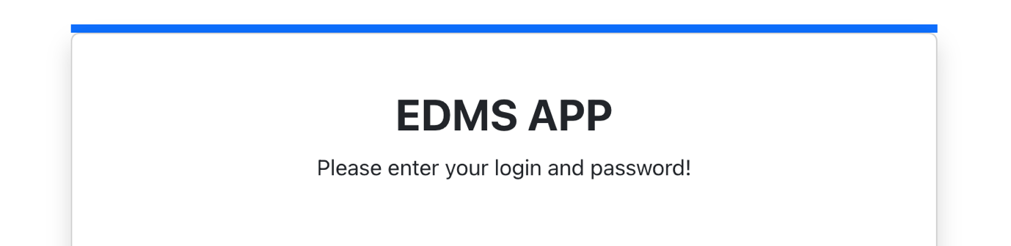

Title component destructured code

function Title(props){

console.log(props);

const { teamName, appName } = props;

return(

<span>{teamName} {appName}</span>

);

}

export default Title;

Test the Immutability of props: